COVID19 Diagnosis Prediction

Group : MaoLiang Liu, Chenlu Huang, Jun Guo

**Table of Contents**

***1. Introduction 2***

***2. Related Work 2***

***3. Solution/Method (Innovations) 3***

***4. Data Understanding 3***

***5. Data Preprocessing 7***

***6. Feature Selection 8***

***7. Sampling 12***

***8. Modeling 14***

***9. Evaluation 15***

**Original sampling 15**

**Randomly over-sampling 16**

**SMOTE oversampling 16**

**Randomly under-sampling 18**

***10. Conclusion 19***

***11. Reference 20***

# 1. Introduction

In December 2019, the first known case of COVID-19 was identified in Wuhan, China. COVID-19, coronavirus disease 2019, is a contagious disease caused by severe acute respiratory syndrome coronavirus 2 (SARS-CoV-2). The disease has since then spread worldwide and resulted in an ongoing pandemic that changes the way of life in every way imaginable. As of August 17, 2021, there are more than 208 million people infected with COVID-19 worldwide and more than 4.4 million deaths because of it. Even in the United States alone, we have around 37 million reported cases and 623 thousand deaths. In fact, according to the CDC, COVID-19 cases have been on the rise recently because of the Delta variant, which causes more infections and spreads faster than earlier forms of the virus that causes COVID-19.

At the beginning of the COVID-19 pandemic, one of the major issues faced by every country around the world is the overwhelming stress the pandemic has put on their medical system. Even one of the most developed counties in the world, the United States, is not prepared to handle the sharp increase in the demand for medical resources let alone other less developed countries. Of course, we have come a long way since then and situations have improved compared to a year ago. However, with the recent increase in COVID-19 cases around the world because of the Delta variant, one couldn’t help but wonder if our medical system is able to properly handle another wave of the COVID-19 pandemic. Therefore, we would like to know whether we can utilize supervised learning to help predict COVID-19 patients. If so, we will be able to help reduce the stress on our medical systems by identifying COVID-19 patients efficiently and reduce the spread of the virus. Of course, this will be most helpful for the less developed countries, such as India, where medical resources are extremely limited.

# 2. Related Work

An article, “Machine learning-based prediction of COVID-19 diagnosis based on symptoms”, was published on January 4, 2021, very similar to what we accomplished in our project. The article talks about the development of a model that detects COVID-19 cases by simple features accessed by asking basic questions. In fact, they used the same public dataset from the Israeli Ministry of Health but from different dates. In the article, they utilized gradient boosting machine model to generate their predictions. In addition to the gradient boosting model, we also utilized multiple models, and then picked the model with the best performance. The dataset used is imbalanced with only 10% positive test result records but in the article, there is no mention of how it was addressed during the data preprocessing or sampling phase. We, on the other hand, utilized different ways of sampling imbalanced datasets to ensure proper training and testing of our models.

# 3. Solution/Method (Innovations)

**Feature Selection**

A wide range of feature selection methods including filter, wrapper, embedded methods are used and compared in order to refine the performance results.

**Imbalanced sampling technique**

To deal with an imbalanced dataset (99% negative and 1% positive), we utilized multiple imbalanced sampling methods to sample the dataset evenly.

**Multiple classifiers**

We are not limited to using only one or two models. Instead, we covered several mainstream models to see what differences in performance they have in predicting our dataset.

# 4. Data Understanding

We utilized the dataset, which contains all the individual tests taken by Israeli citizens since February 2020, retrieved from Israeli Ministry of Health websitefor our project. Both the website and the record within the dataset is in Hebrew but, with the help of Google translator, we were able to translate the contents to English and ensure our understanding of the dataset is correct. The dataset contains the below 10 columns:

1. date: Arrival date of the test at the lab in DD/MM/YY format
2. cough: Did cough symptoms appear before testing? 1 –Yes, 0–No, NULL –Unknown
3. fever: Did fever appear before testing? 1 –Yes, 0 –No, NULL –Unknown
4. sore_throat: Did sore throat symptoms appear before testing? 1 –Yes, 0 –No, NULL –Unknown
5. shortness_of_breath: Did cough shortness of breath symptoms appear before testing? 1 –Yes, 0 –No, NULL –Unknown
6. head_ache: Did headache symptoms appear before testing? 1 –Yes, 0 –No, NULL –Unknown
7. gender: test taker's sex: male/female/ NULL (unknown)
8. corona_result: Results of first Covid-19 test, by category:

Positive –carrying Covid-19

Negative –not carrying Covid-19

Other –Not tested, in testing, inconclusive

1. age: Indicator of the test taker's age -60 or over (1) or below 60 (0)
2. test_indication: What is the indication for testing?

Abroad –arrived from abroad

Contact_with_confirmed –contact with a confirmed case

Other –other indication or not specified

The dataset is constantly updating but, due to the size and the computation power of our laptops, we have limited our dataset to around 500 thousand records by limiting the dates to be between May 30, 2021 and July 25, 2021.

Within our dataset, we have the below null values in the age and gender columns:

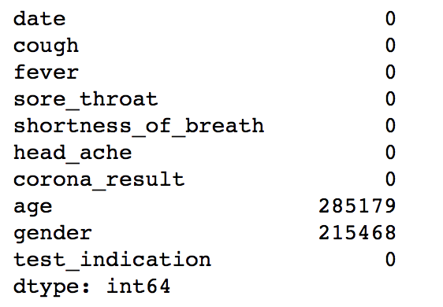

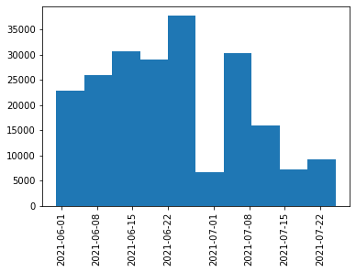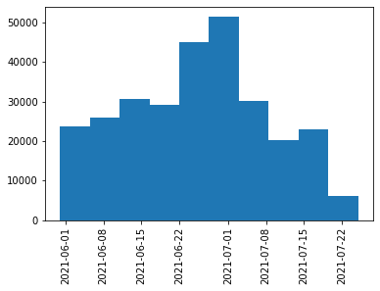

We visualized the distribution of our 5 symptoms below and noticed that they are highly skewed with over 75% being 0.

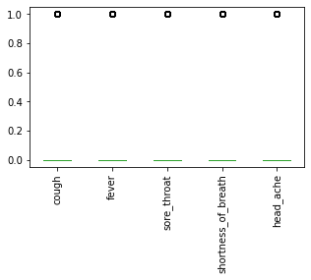

We also broke down the 5 symptoms against corona_result to see if there are any obvious patterns or linkage between the symptoms and the test results. Based on the comparison graphs below, even though there’s no obvious direct link between the symptoms and positive covid result, it does show that these 5 symptoms are more likely to be present in the positive result cases than negative.

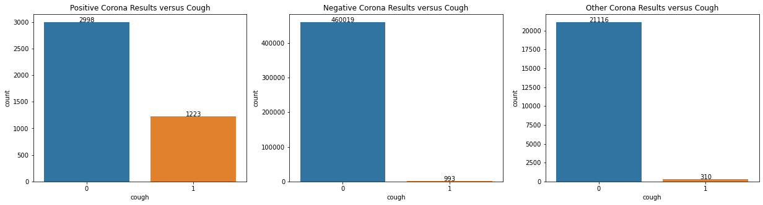 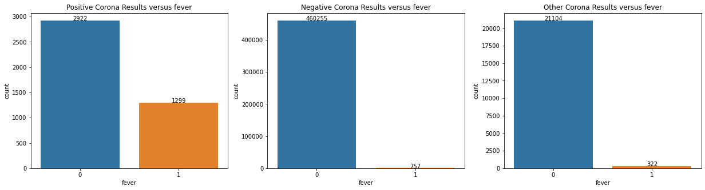 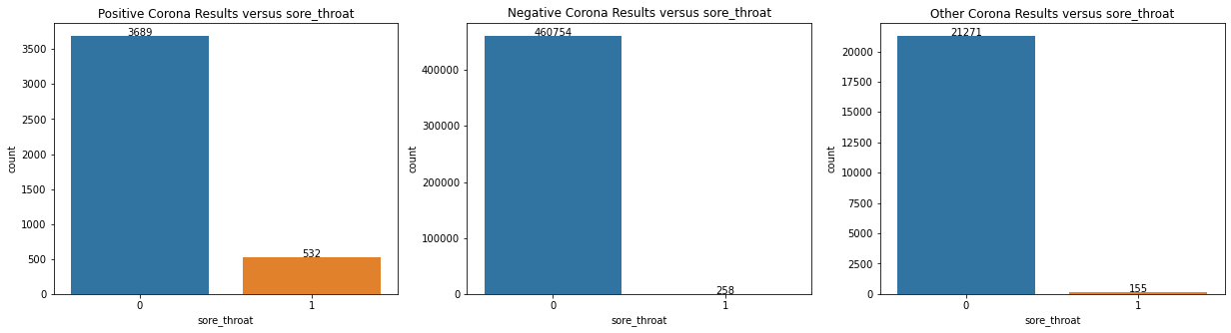 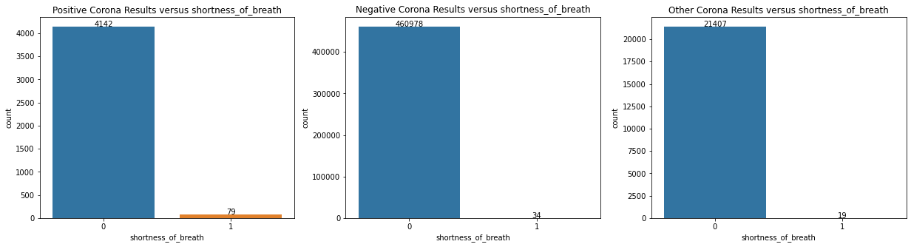 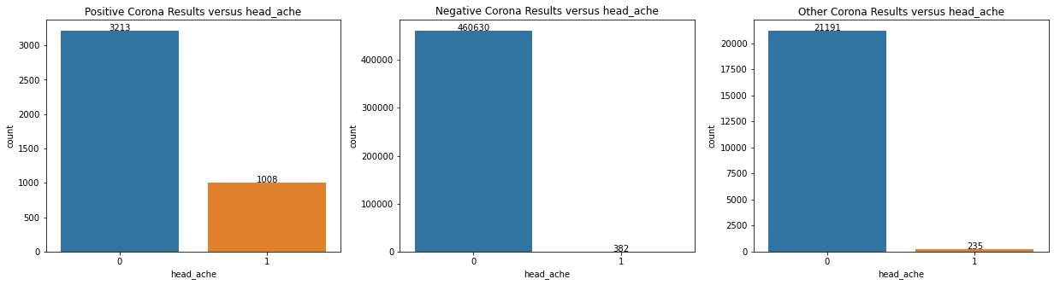

We created the below corona_result count graph to get a better understanding of its distribution. Base on the graph, our dataset is highly imbalanced toward the negative result. In fact, less than 1 percent of our entire dataset is positive.

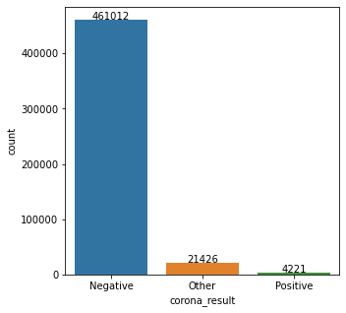

Lastly, to see if there’s a pattern to the number of COVID tests taken over time, we have created the below three graphs that show the daily counts of COVID tests based on the test result. We have also group COVID test counts from daily to weekly bins so we can better determine if there’s a pattern in the number of tests taken over time. Overall, there seems to be a general upward trend in the number of people getting covid tests.

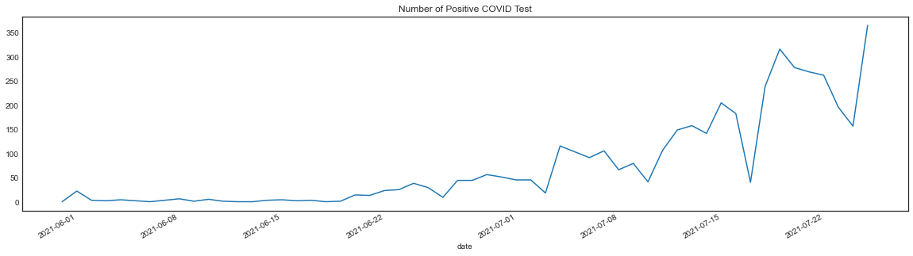 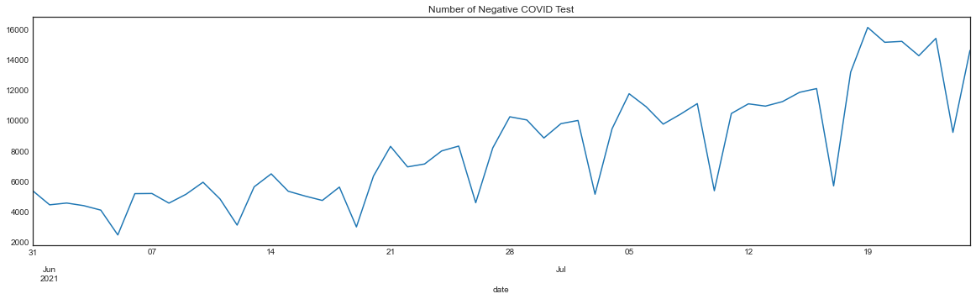 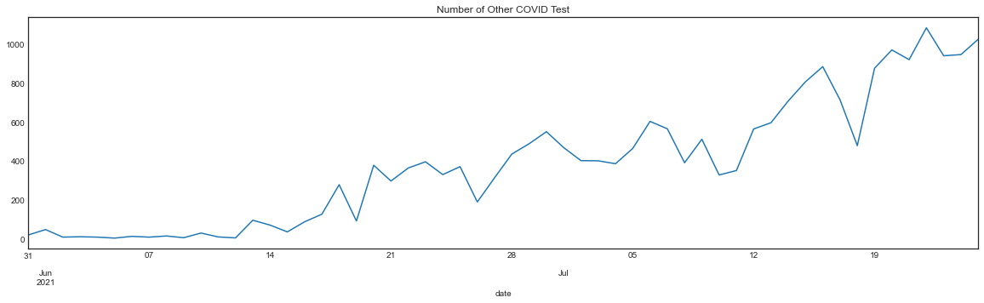 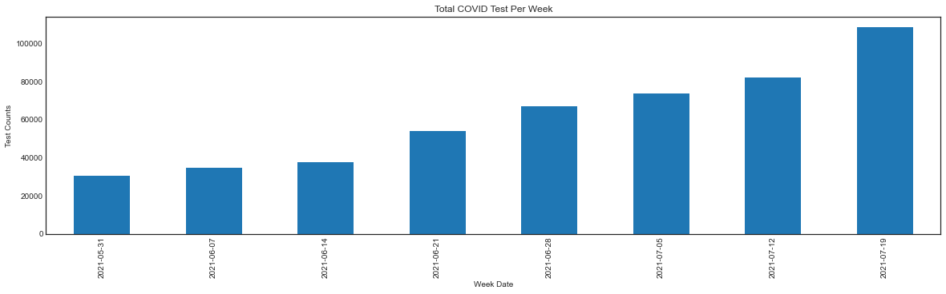

# 5. Data Preprocessing

For the test result marked as “other”, i.e. not tested, in testing, inconclusive, we dropped these rows as they are not meaningful to the prediction. The prediction target variable is expected to be either positive or negative.

For the two features found with missing values, the missingness of the data is significant and completely at random. As the age and gender are nominal data types, we filled in those empty cells with a string instead of imputing using an average or KNN. At the end of this section, we also compared if dropping those rows with missing values can better improve the performance.

|  |  |  |
| --- | --- | --- |
|  | **Total** | **Percent** |
| **age** | 275466 | 0.592103 |
| **gender** | 208245 | 0.447614 |

# 

# 6. Feature Selection

With regard to performance evaluation, next to the true positive rate, the false negative is more important than the false positive as false positive cases can be further confirmed using blood test for example, but a high false negative rate and negligence of false negative cases will lead to delayed treatment of the infected individuals and extending the spread of the infection.

As suggested by the confusion matrix, the true positive rate is significant and it will outweigh the false negative or positive rates if we use accuracy, precision or recall scores;

those scores may not be sensitive to false negative or positive rate. Instead, we used performance metrics tailored for imbalanced data. For example, sensitivity and specificity quantifies the ability to avoid false negatives and false positives. But still these scores do not look very promising; we expect to see more metrics above 90%. To maximize the performance, we resorted to feature selection to eliminate the redundant features.

|  |  |  |
| --- | --- | --- |
|  | **Method** | **Original** |
| **0** | Balanced Accuracy | 0.824516 |
| **1** | Sensitivity | 0.994691 |
| **2** | Specificity | 0.654340 |
| **3** | AUROC | 0.824516 |
| **4** | F1 | 0.684547 |
| **5** | Geometric Mean | 0.806763 |
| **6** | Macro Average MAE | 0.175484 |

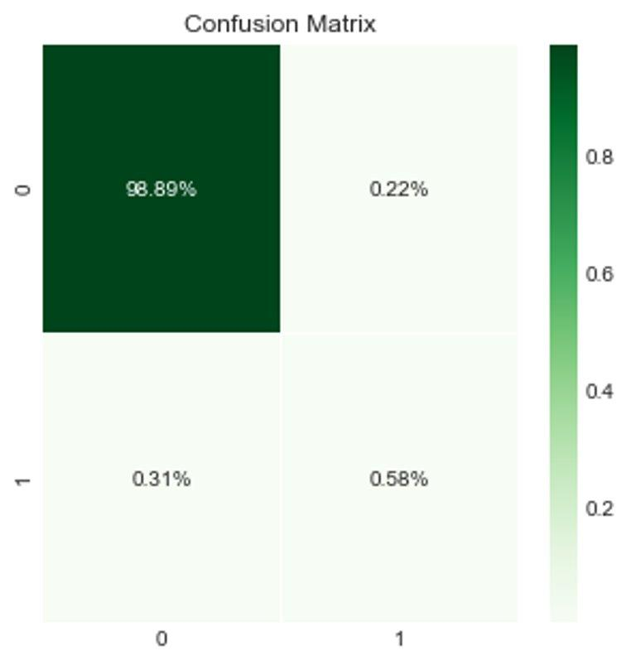

The correlation matrix below reveals the independence of each feature. As indicated by the lightness of the color, the correlations scores are all quite low, the highest being 0.43. This suggests that all features are independent of each other.

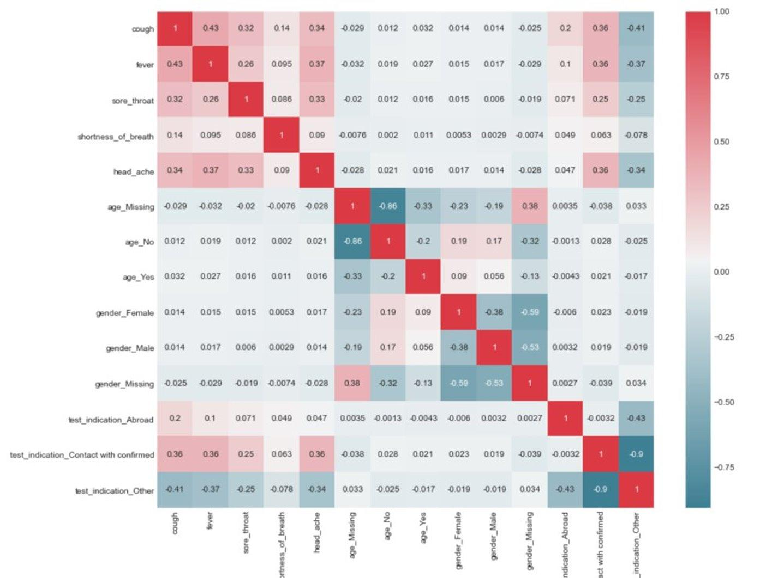

We utilized feature importance generated by random forest, PCA and REFCV to find out how many features should be selected. All 3 graphs below show that including the top 6 features will be sufficient for the prediction.

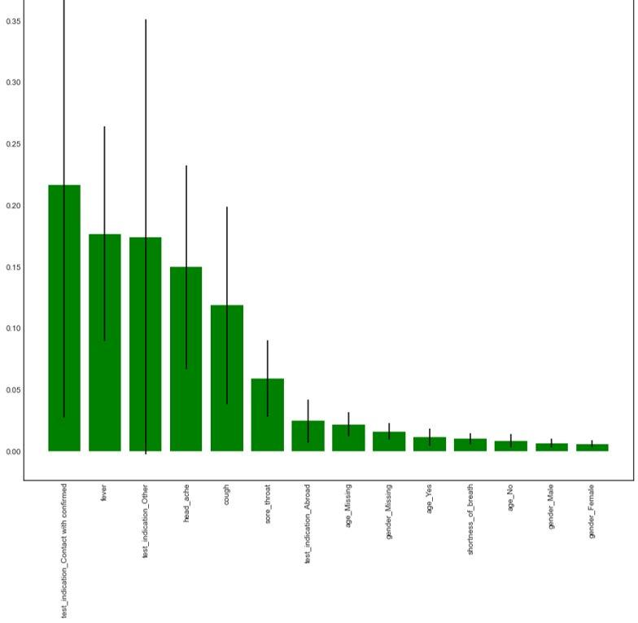

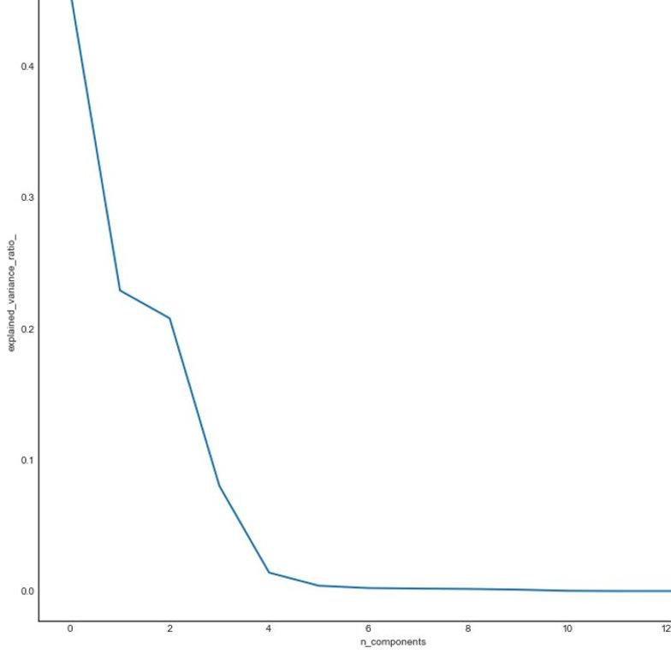

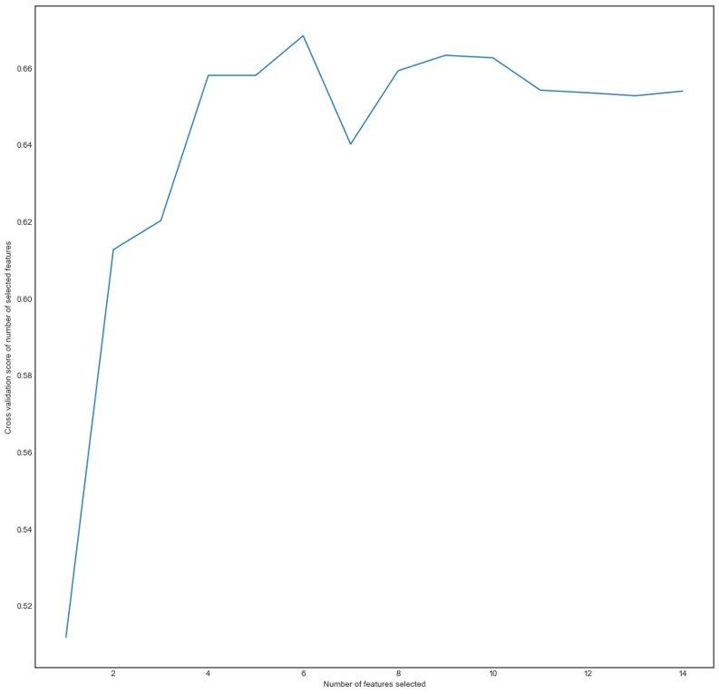

To find out how many features should be selected, the table below summarizes the performance scores from 4 different methods. SelectKBest-chia2 differs from the other 3 methods on the last feature to be selected: it selects shortness of breath while the other 3 methods select test_indication_other. This is probably due to the fact that SelectKBest-chia2 is correlation-based, so the selection mirrors the correlation matrix, while the other 3 methods are information-gain-based or information gain weighted by the probability of reaching that node in tree-based models, so they share the same selection.

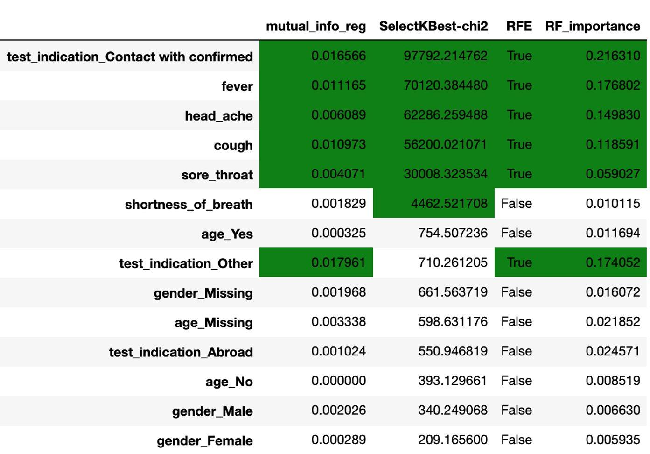

In order to compare which selection method delivers a better performance, we compute the performance of datasets with two different selections in comparison to the performance of the original dataset with no feature selected. The dataset choosing test_indication_other as the last feature has higher performance than the dataset choosing shortness of breath. We can confidently finalize the 6 features with the last one being test_indication_other.

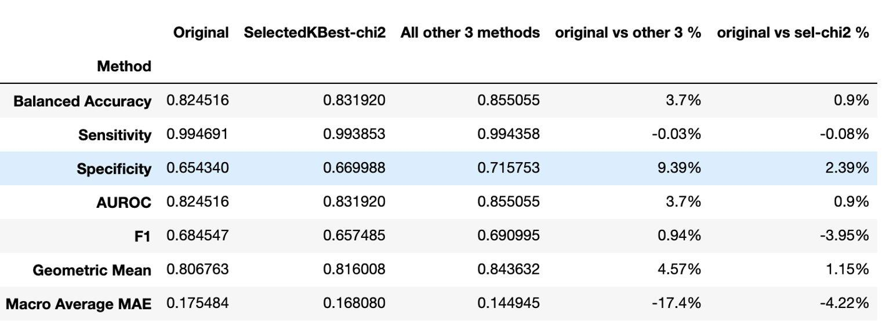

Finally, after selecting the 6 features, we compared whether dropping the rows with null values can improve the performance. It turns out that dropping will impair the performance. Indeed, dropping the rows with null values may drop positive cases in parallel, thus making the data even more imbalanced. Since age and gender features are not selected, it would make no difference either keeping those rows filled or unfilled. We used the filled dataset so that more rows, especially those with positive results, can be kept. We concluded with a dataset with 6 features selected and the missing values filled.

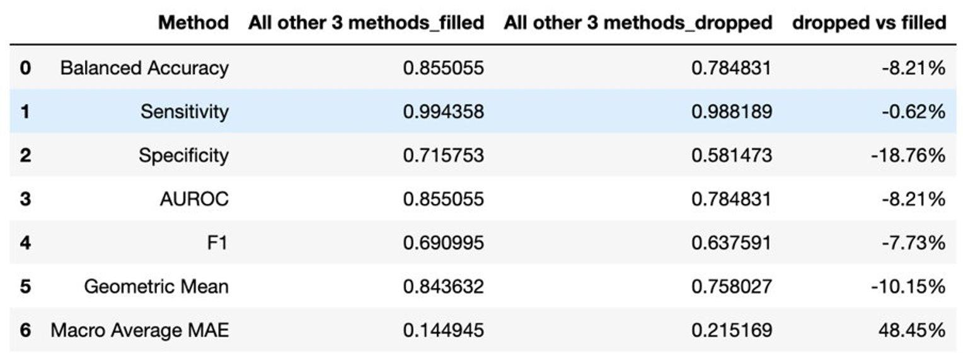

# 7. Sampling

Due to the highly imbalanced property of our dataset, the prediction results derived from vanilla original dataset may be biased and perform badly from the perspective of predicting the positive instance which is the minority class. To emphasize the effect of positive samples in our training dataset, we decided to leverage several sampling techniques for imbalanced data.

The sampling method we are going to use is from **Imblearn** package. The strategy to fight with imbalanced data is to either increase the number of samples which are under-represented or downsize the scale of the samples which belong to the majority class. The naive oversampling and under-sampling method provide us the ability to randomly duplicate or delete samples from the original dataset. However, the repeating samples could be an issue. Therefore, we also applied the variant method of oversampling method – SMOTE (Synthetic Minority Oversampling Technique) which generates new samples by interpolation. There is also a technique called ADASYN (Adaptive Synthetic) which focuses on generating new samples which are similar to original samples and are wrongly classified by KNN methods. We did not apply this method to our dataset because of the poor features of our dataset and the memory constraints to run ADASYN. The different sampling methods are illustrated by the following charts.

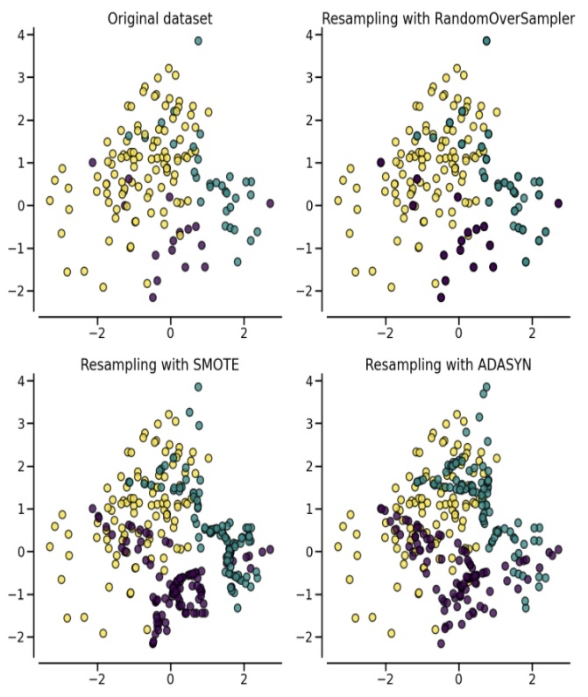

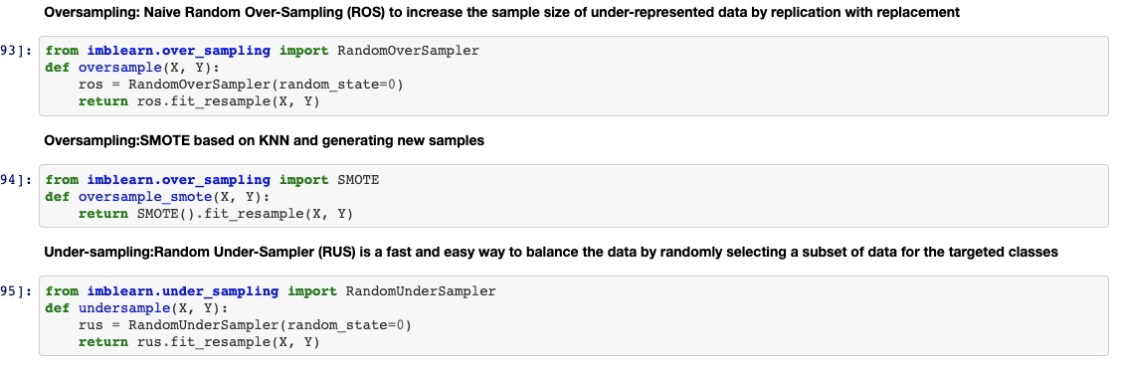

Different sampling methods are used in our prediction, including original sampling, random over-sampling, SMOTE, random under_sampling. We compared the performance of our models when applying various sampling technologies.

# 8. Modeling

Several mainstream models were adopted in training and prediction of our dataset such as **Perceptron, Decision Tree, Gaussian Naive Bayes, Random Forest, GradientBoostingForest, XGBoost and Neural Network.**

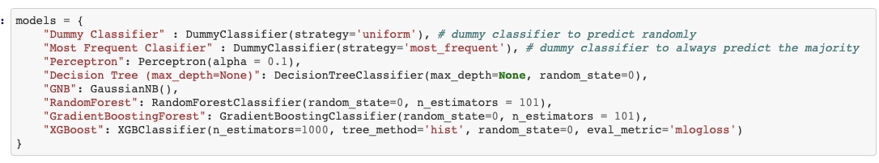

The parameters of the above classifiers were tuned through demo tests to ensure that they have the best performance in prediction. For the neural network, we used one hidden layer and sigmoid activation function for the final output.

We introduced two other classifiers: **dummy classifier** which randomly predicts the results to be positive or negative and most frequent classifier which always predicts the samples to be the majority class. We used these two classifiers because we have known that our dataset is highly imbalanced so that the accuracy is less informative though the accuracy is high. Therefore, we used these two dummy classifiers serving as the baseline performance indicators to give us a reference on how well our models perform in the sampling dataset. We trained our models and make predictions using the following the steps below:

1. Using Stratified K-Fold splitting (k = 10) method to split train-test samples
2. For training data, using different sampling methods (over sample, SMOTE, under sample) to resample the training data and keep test data intact.
3. Run model to fit and predict for each model and record the metrics (for training data and test data)
4. Calculate the average metrics for 10 folds.

The code in Jupyter notebook is shown below:

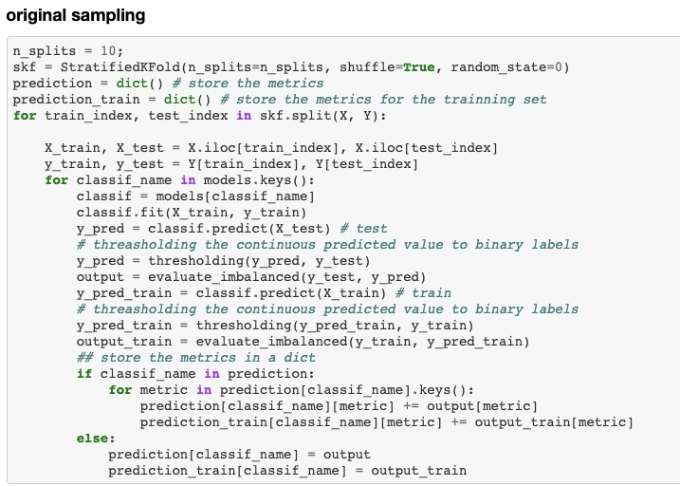

In the case that some classifiers predict continuous values instead of categorical results, we used the **thresholding** method to map continuous floating value to categorical labels and maximize the g-mean value of the prediction.

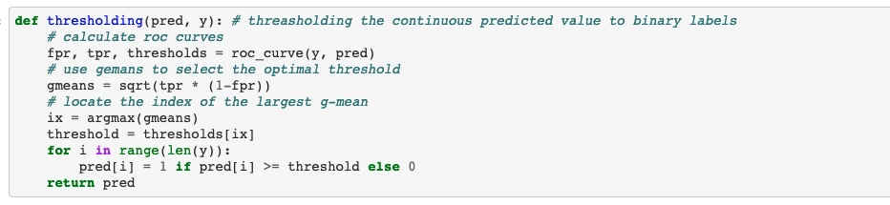

# 9. Evaluation

The performances from different models were sorted based on their AUROC in descending order.

## Original sampling

1. Test data

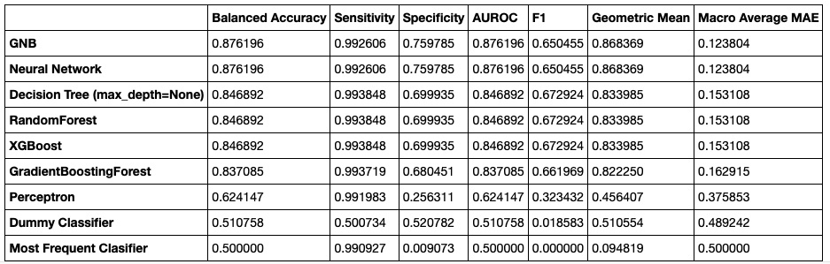

1. Train data

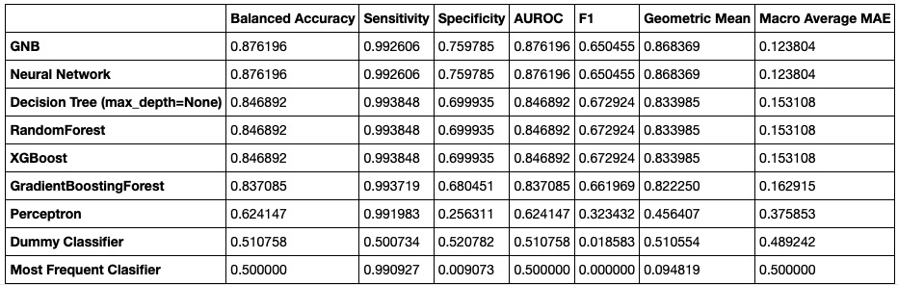

The Gaussian Naïve Bayes and Neural Network perform the best with AUROC achieving 0.876 among all models but the differences between models are nuanced. The Perceptron has a substandard performance because it cannot predict positive samples well. The two dummy classifiers perform the worst. Noticeably, the models have the same performance on test data as on train data which means our models are not overfitting on the train data.

## Randomly over-sampling

1. Test data

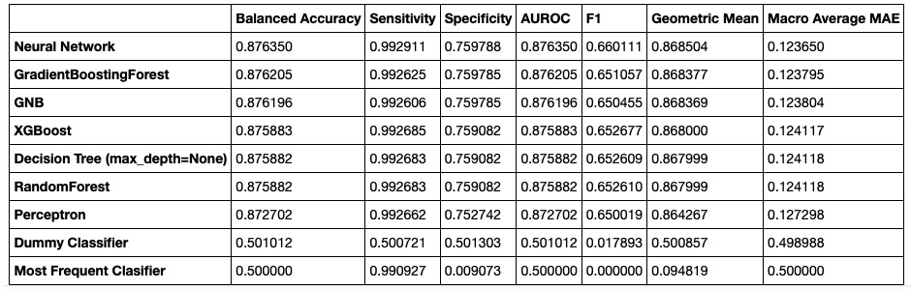

1. Train data

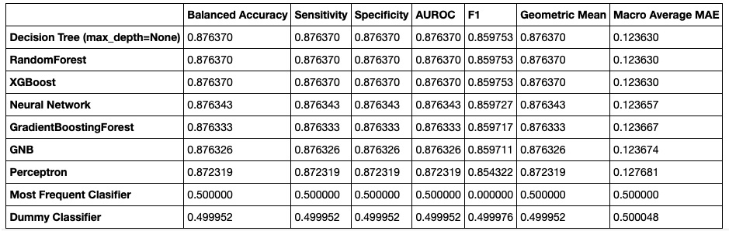

The performance is similar compared with that of original samples. However, there are two main differences.

1. The performance from Perceptron is aligned with other models
2. Our models may be overfitting on the train data according to the F1 score.

## SMOTE oversampling

1. Test data

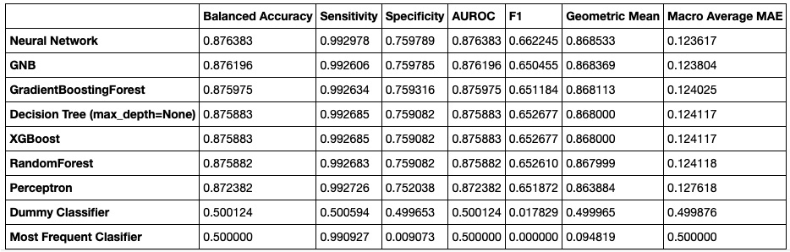

1. Train data

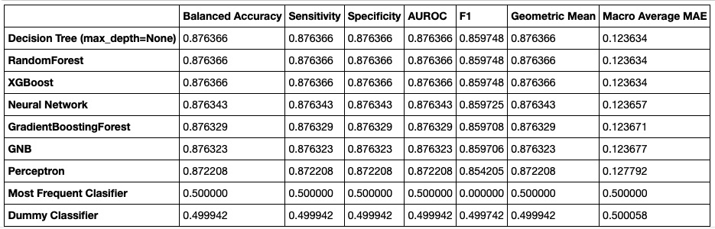

We achieved similar results with over-sampling using SMOTE. The Neural Network turns out to be the best and we are not overfitting on train data.

Below is the decision tree graph generated from model fit with train data oversampled using SMOTE. We can have a basic understanding on how the decision tree predicts the results. The detail is not very clear due to too many cases in the leaf layer. However, the depth of the tree is only 7 layers.

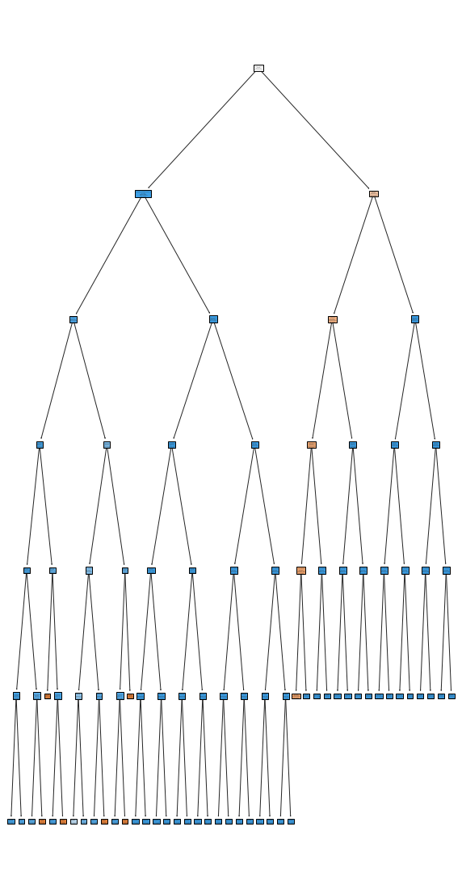

## Randomly under-sampling

1. Test data

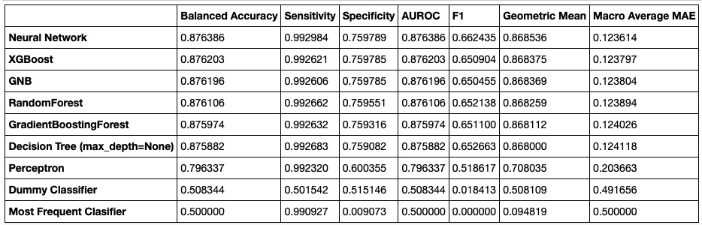

1. Train data

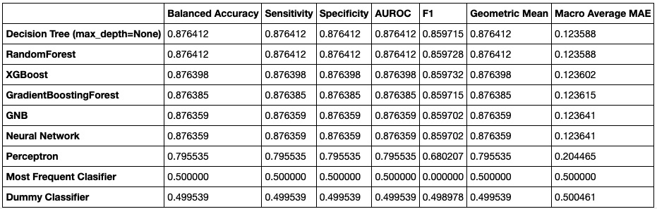

The performance of different models is almost the same except that the Perceptron is slightly worse than the other models.

# 10. Conclusion

|  |  |  |
| --- | --- | --- |
| **Sampling Method** | **Best Models** | **AUROC** |
| Original sample | GNB, Neural Network | 87.62 |
| Randomly over sample | Neural Network | 87.64 |
| SMOTE | Neural Network | 87.64 |
| Randomly under sample | Neural Network | 87.64 |

The table above summarizes the best performing models from each sampling method. The Neural Network performs best in all four sampling methods. However, the difference in performances between different models is not significant and the performance on the original dataset is not very high which means the models may be underfitting due to the nature of this dataset.

We believe the possible reasons we were unable to achieve ever higher performance are:

1. The hidden pattern behind the COVID-19 data is continuously changing over time due to virus mutation and that is why we might not be able to obtain a good prediction based on past data.
2. The features may not be well labeled and subject to bias. For example, some features are binary but it may be subjective to categorize those symptoms. Besides, the Israeli data document comments that the five symptoms labeled are merely the most representative ones but there are more symptoms to indicate a positive infection. We utilized 6 binary features which produce 64 combinations of features. For each combination, the results of diagnosis are not unary which makes these features not well-suited for predicting diagnosis results.

Nonetheless, we believe our Neural Network model can be utilized to help efficiently identify COVID-19 patients as a preliminary filter and thereby, help reduce the stress on our medical systems and the spread of the virus.

# 11. Reference

* <https://en.wikipedia.org/wiki/COVID-19>
* <https://www.cnn.com/interactive/2020/health/coronavirus-maps-and-cases/>
* <https://www.cdc.gov/coronavirus/2019-ncov/variants/delta-variant.html>
* <https://www.nature.com/articles/s41746-020-00372-6#sec6>
* <https://github.com/guojunseven/Data-Mining-Project/blob/master/COVID19%20Diagnosis%20Prediction.ipynb>
* <https://www.kaggle.com/kanncaa1/feature-selection-and-data-visualization>
* <https://www.kaggle.com/prashant111/comprehensive-guide-on-feature-selection>
* [https://imbalanced-learn.org/stable/references/metrics.html#module-imblearn.metrics](https://imbalanced-learn.org/stable/references/metrics.html)
* <https://en.wikipedia.org/wiki/Template:COVID-19_pandemic_data>
* <https://www.nytimes.com/interactive/2021/us/covid-cases.html>
* <https://ourworldindata.org/coronavirus-data>
* <https://github.com/CSSEGISandData/COVID-19>
* <https://www.cdc.gov/coronavirus/2019-ncov/variants/delta-variant.html>
* [https://imbalanced-learn.org/stable/over_sampling.html#naive-random-over-sampling](https://imbalanced-learn.org/stable/over_sampling.html)
* <https://data.gov.il/dataset/covid-19>